M2M
Dthing Technical Notes
Third-party java source code build guide
CONTENT
This document describes the release information for CMCC 20150120

DISTRIBUTION

 | AUTHOR | APPROVAL |  | QUALITY  N.A IF NO APPLICABLE
 | AUTHOR | LEVEL 1 | LEVEL 2 | QUALITY  N.A IF NO APPLICABLE
FUNCTION
NAME
DATE
VISA

Document history

Table of contents
Document history 3
Table of contents 4
1 Setup Environment 5
2 Java build tool introduction 6
3 static build java source into VM lib 8

Setup Environment
- Install tools java source build
  - JDK tool for java source compiling (JDK version >= 1.6).
Download it form Oracle website: http://www.oracle.com
  - Ant tool for java source make
Download it from Apache website: http://ant.apache.org
  - Python tool for build process (Python version >= 2.5)
Download it from Python website: https://www.python.org
  - Dex tool for dex jar package generate.
Download it from android website: https://developer.android.com

- After tools installed, setup build environment.
When unzip Java_build.7z, you can find a script file build.bat under it.
Open it by text editor, and you can find there are four lines for setting up above tools into build environment.
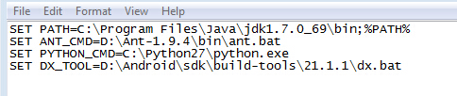
Change above variables follows your own system variable or tools location. And then save it.

Java build tool introduction
- Java build tool file structure:
When unzip Java_build.7z, the fold structure is shown as below:
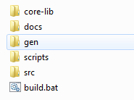

Core-lib: DThing framework, this directory name and its content cannot be changed.
Docs: The document of Java build tool.
Gen: The automatically generated folder for temp and final files.
Scripts: Build script files.
Src: The source java files directory if you use it.
Build.bat: the build script.

- How to use this tool:
  - Follows paragraph < 1 SETUP ENVIRONMENT> to setup your environment.
  - <Windos key> + R, input cmd to launch a command shell window
  - Enter java build directory as below:
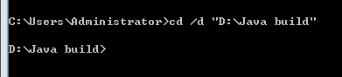

  - Input <build.bat check> to check current environment whether is setting up success.
  - If no error prompt, Input <build.bat start> to start java build.
  - Input <build.bat clean> to clean previous build result.
  - Input <build.bat help> to learn more about how to build java source.

There 2 ways to input java source files:
- Put all java source codes including packages into src folder, and then run <build.bat start> directly to build java source codes.
- Run <build.bat start --source=[java source code path]>, [java source code path] must be an absolute path, like: “D:\java\cmcc\third-party”.
Here is a demo code <test.java> which is under src folder.

- Build result:
When build success, the generated jars will be shown as following:
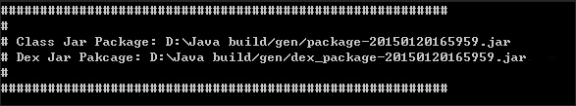
Bytecode jar package is named as package and timestamp combination.
Dex jar package is added “dex_”prefix according to bytecode jar package.

static build java source into VM lib
- Third-party source code position
Put all java source code into folder java/tp_src of DVM root. Keep the source structure and package name without any changes.
Just be caution: Delete any unused, backup or temporary java source files, otherwise they will be built into final library since all java files will be compiled under that folder.

- Check your build environment.
Change the file antbuild.properties to follow your own PC environment as below:
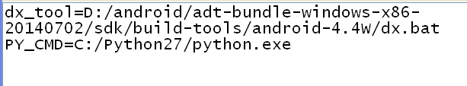

- Input <ant -buildfile antbuild.xml tp> on command to start third-party build. And the build result will merge with core-dvm automatically.

